A Unified Framework for Crime Prediction and Real-Time Surveillance

# Abstract

The integration of crime prediction models and intelligent video surveillance has the potential to transform urban public safety strategies. This paper consolidates insights from multiple research studies on crime analysis, machine learning, deep learning, big data analytics, and real-time violence detection. Building on these findings, we propose a unified research agenda structured around seven core objectives, including the development of machine learning models for crime prediction, the integration of external data, real-time violence detection, hotspot analysis, computational efficiency in surveillance, spatiotemporal interpretability, and comparative evaluations of learning architectures. The paper aims to guide future research toward building scalable, interpretable, and ethically sound crime prevention systems. 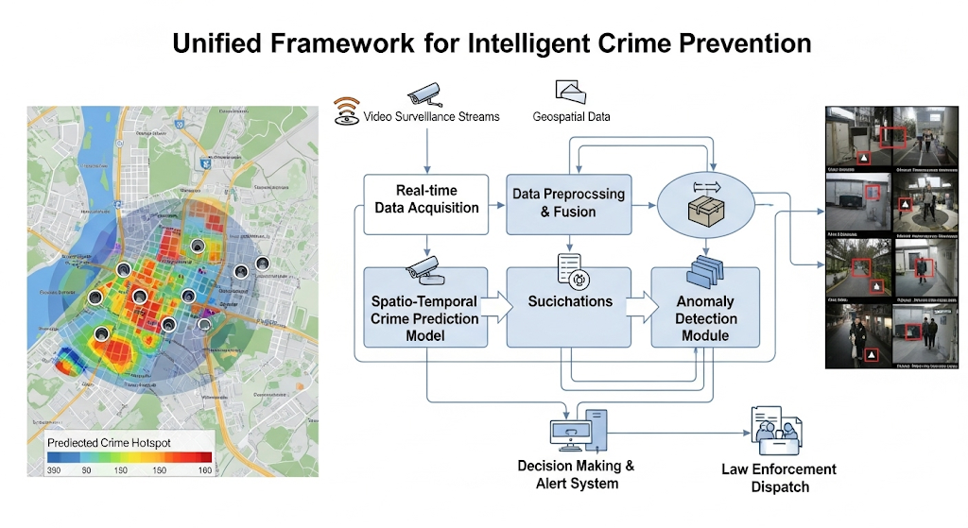

# 1. Introduction

Urban crime presents dynamic and complex challenges that traditional statistical methods cannot fully capture. Recent years have seen significant advances in machine learning (Himanshi, 2022), big data-driven inference (Wang et al., 2016), deep learning architectures (Cheng et al., 2018; Preprint 2024), and intelligent video surveillance (Sreenu & Durai, 2019). Despite progress, the literature reveals gaps: models often remain city-specific, lack real-time responsiveness, or operate as isolated systems without integration between prediction and surveillance. This paper synthesizes findings from key studies and articulates objectives for a holistic framework that addresses prediction accuracy, external data integration, interpretability, and real-time deployment.

# 2. Literature Review

Several strands of research inform our objectives. Early works such as Crime Analysis in Chicago City (2019) and The Windy City’s Dark Side (2024) focused on hotspot identification and statistical exploration of trends. Machine learning studies, including Chicago Crime Analysis using R (2019) and Comparative Analysis (2023), highlight the utility of models like KNN, Random Forest, and XGBoost in predicting arrests and thefts. Deep learning research—Forecasting Crime with Deep Learning (2018) and Deep Learning Based Crime Prediction Models (2024)—demonstrates the promise of CNNs, RNNs, and hybrid architectures, especially when external datasets such as weather, public transport, and POI are incorporated. Big data perspectives (Wang et al., 2016) emphasize the role of urban mobility and POI data in enhancing inference. Meanwhile, surveillance-focused works (Sreenu & Durai, 2019; Real-Time Violence Detection 2021–2024) propose CNN-LSTM and MobileNetV2-based systems for violence detection, though computational efficiency and scalability remain concerns.

# 3. Research Objectives

1. Develop and Compare Machine Learning Models for Crime Prediction: Implement and test multiple machine learning models using Chicago crime data (2001–2023), comparing XGBoost, Random Forest, and KNN for tasks like theft prediction while addressing data imbalance (Himanshi, 2022; Comparative Analysis, 2023).
2. Enhance Crime Forecasting with External Data Integration: Improve predictive accuracy by augmenting crime data with weather, public transportation, and census information, following frameworks such as RNN+CNN hybrids (Cheng et al., 2018; Wang et al., 2016).
3. Propose a Real-Time Violence Detection System Architecture: Design a lightweight CNN-LSTM or MobileNetV2 system for real-time violence detection with automated alerting mechanisms (Sreenu & Durai, 2019; Real-Time Detection, 2021–2024).
4. Implement a Data-Driven System for Identifying Crime Hotspots: Use clustering and visualization tools (e.g., Power BI) to analyze spatiotemporal hotspots and trends (Crime Analysis in Chicago City, 2019; Windy City’s Dark Side, 2024).
5. Design a System for Improving Real-Time Computational Efficiency: Propose a priority-based scheduling algorithm to allocate computational resources efficiently for real-time surveillance (Real-Time Detection Using CNN-LSTM, 2021).
6. Evaluate Spatiotemporal Features and Model Interpretability: Analyze how features like location and time drive predictions, using interpretability tools such as SHAP (Comparative Analysis, 2023).
7. Conduct a Comparative Analysis of Machine Learning and Deep Learning Architectures: Evaluate traditional ML models versus deep learning architectures under different conditions, including ablation studies on external features (Deep Learning Prediction Models, 2024).

# 4. Methodology Framework

To operationalize the objectives, the following methodological framework is proposed:  
- Data Preparation: Use Chicago’s crime dataset (2001–2023), ensuring preprocessing (cleaning, normalization, handling imbalance).  
- Model Development: Train baseline ML models (Random Forest, XGBoost, KNN) and advanced deep learning models (CNN, RNN, hybrid CNN+RNN).  
- External Data Integration: Merge weather, census, and transport datasets to evaluate performance improvements.  
- Real-Time Surveillance: Prototype CNN-LSTM/MobileNetV2 systems for violence detection with edge-computing capabilities.  
- Hotspot Visualization: Implement spatial clustering and Power BI dashboards for hotspot detection.  
- Computational Optimization: Design scheduling algorithms to allocate GPU/CPU resources efficiently for high-probability streams.  
- Interpretability: Apply SHAP and feature importance analyses to ensure transparency and accountability.

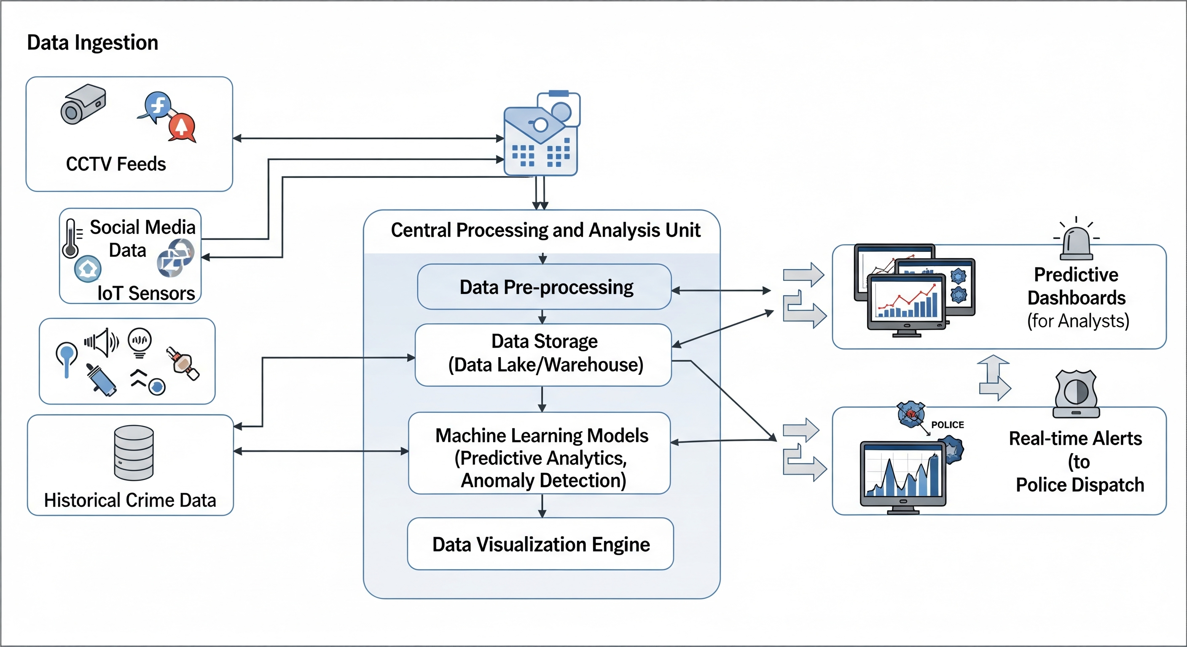

# 5. Conclusion

This paper consolidates diverse research findings into a unified set of objectives for crime prediction and intelligent surveillance. By aligning machine learning, deep learning, and big data techniques with real-time video analysis, future systems can move from reactive responses to proactive prevention. The integration of interpretability, computational efficiency, and ethical safeguards ensures that these systems remain both technically robust and socially responsible.

# References

1. Sreenu, G., & Durai, M. A. S. (2019). Intelligent video surveillance: A review. Journal of King Saud University-Computer and Information Sciences.
2. Himanshi, H. (2022). Analysing Crime Patterns using Machine Learning: A case study in Chicago. Research Project.
3. Anonymous. (2019). Chicago Crime Analysis using R Programming. Data.cityofchicago.org.
4. Wang, H., Kifer, D., Graif, C., & Li, Z. (2016). Crime Rate Inference with Big Data. Proceedings of the 22nd ACM SIGKDD Conference.
5. Anonymous. (2023). A Comparative Analysis of Multiple Methods for Predicting a Specific Type of Crime in the City of Chicago. Research Paper.
6. Cheng, Y., et al. (2018). Forecasting Crime with Deep Learning. IEEE Big Data.
7. Anonymous. (2019). Crime Analysis in Chicago City. Research Paper.
8. Anonymous. (2024). Deep Learning Based Crime Prediction Models: Experiments and Analysis. Preprint.
9. Anonymous. (2024). The Windy City’s Dark Side: A Statistical Exploration of Crime in the City of Chicago. Research Paper.
10. Anonymous. (2024, March). Real Time Violence Detection and Alert System. Research Paper.
11. Anonymous. (2021, April). Real-Time Violence Detection Using CNN-LSTM. Research Paper.